**Candle Software**

GRBL controller application with G-Code visualizer written in Qt.

Supported functions:

* Controlling GRBL-based cnc-machine via console commands, buttons on form, numpad.
* Monitoring cnc-machine state.
* Loading, editing, saving and sending of G-code files to cnc-machine.
* Visualizing G-code files.

**System requirements for running "Candle":**

* Windows/Linux x86
* CPU with SSE2 instruction set support
* Graphics card with OpenGL 2.0 support
* 120 MB free storage space

**Build requirements:**

Qt 5.4.2 with MinGW/GCC compiler

**Downloads:**

For GRBL v1.1 firmware

* Windows: [candle_1.1.7.zip](https://github.com/Denvi/Candle/releases/download/v1.1/Candle_1.1.7.zip)
* Linux: [candle_1.1.7.tar.gz](https://github.com/Denvi/Candle/releases/download/v1.1/Candle_1.1.7.tar.gz)

(for GRBL v0.9 and below use Candle 1.0)

"Candle" main window: [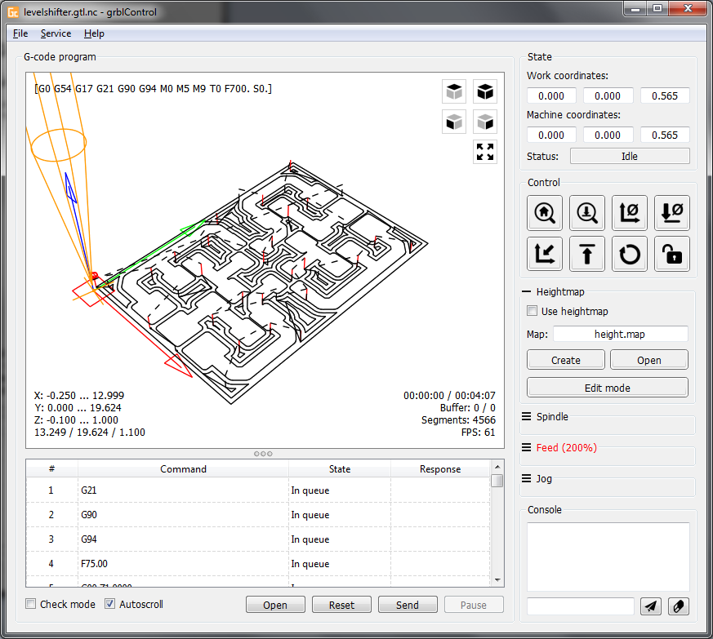](https://github.com/Denvi/Candle/blob/master/screenshots/screenshot_heightmap_original.png)